The inclusion of environmental issues as an important component of science education

Jindřiška Svobodová, Tomáš Miléř, Jan Hollan

Masaryk University

Author Note
Jindřiška Svobodová, Tomáš Miléř and Jan Hollan, Department of Physics, Faculty of Education, Masaryk University, Brno, Czech Republic
This contribution has been prepared within a grant of Operational Program Education for Competitiveness: Modules of Innovation in the Integration of Teaching Modern Physics and Chemistry OP VK CZ.1.07/2.2.00/28.0182
Correspondence concerning this article should be addressed to J. Svobodová, svobodova@ped.muni.cz

Abstract
This paper describes the development of a new laboratory course designed to integrate science education. We introduced supplementary laboratory activities for future science teachers that provide them with a research experience. The presented activities include the following aspects of physics: solar energy, the climate and weather systems, energy laws, invisible and visible radiation and so on. We illustrate how knowledge of physics can be used in environmental education, on example of radiative fluxes which are around us. Our laboratory course can be used as a stand-alone unit or embedded in a larger unit on climate change.
Keywords: environmental physics, project work, laboratory activities, science literacy, emittance
The inclusion of environmental issues as an important component of science education

Introduction
We are developing a course for future science teachers with aspiration to improve the knowledge of physical factors affecting climate by experimental activities. Observations and design of experiments are essential parts of physics education. Environmental physics is a suitable interdisciplinary topic for introducing students to scientific process. If we chose to include environmental topics in the curriculum for future teachers, where would it fit? The possibilities are numerous, we have chosen an approach on balance between concrete versus abstract understanding to climate change physical concepts. Obvious curriculum choices for environmental education are – in biology: carbon cycle, physical requirements of habitat; in chemistry: water quality, CO₂ sources and sensing, soil analysis; in geography–earth science: the Earth’s orbit, seasons, atmospheres on other planets, land vs. water energy relationships and eventually in physics: light spectrum, heat vs. temperature, density and distribution of gases, mechanism of greenhouse effect, energy budgets etc.
The goal of the project was to develop several modules helping to implement the abilities used by scientists in their work. In addition, we have included students own experimental and laboratory work. Like John Dewey, educational-conceptual-guru, we believed that (“John Dewey,” 2012) “students thrive in an environment where they are allowed to experience” the real problems and step by step interact with them. In our activities we provided students with opportunities to engage in processes of investigation. We utilized Devey's ideas to design science courses focused on experimental methods and data interpretation. The course provides students with opportunity to plan their own experiments to test hypotheses, to make generalizations and assumptions and to link empirical facts to the solutions of environmental problems. The course also includes several demonstration experiments to avoid misunderstandings of radiation balance, which are explained in right terms of general physics.
In this paper we present four sample laboratory and outdoor measurements: 1. Noncontact temperature measurement, 2. Illuminance and albedo measurements, 3. A more broadband solar albedo, 4. Cooling and warming measurements. All the measurements can be modified or extended according to the school's teaching requirements and available facilities. In supplemental online materials at http://amper.ped.muni.cz/gw/activities we provide theoretical background of physical phenomena discussed below.

Method of Implementation
The first part of our laboratory course is named “Visible & Nonvisible Radiation”. The students learn from this lab activity a lot about the relationship between insolation and temperature. These activities about visible (light) and invisible (UV, infrared) radiation are supported by special textbook. Students are introduced to work in open-ended labs by question (Q:).
Students can prepare specified experiments and activities in a laboratory. Every student or teacher can acquire relatively cheap equipment for many tasks today, sensors and PC measuring tools with data loggers and respective software. Some experiments can be designed as outdoor activities to promote interest of students in natural environment. They work with light sources, filters, photocell detectors, infrared thermometers, radiometers, thermometers and dataloggers. They study different surfaces properties for incident light, they can see that infrared radiation is reflected in the same manner as light, and that infrared in some cases behaves like light and in other cases it behaves very differently.

Sample laboratory and outdoor measurements

Noncontact temperature measurement
Q1: What do we need to consider when using an IR thermometer?
Q2: Do all objects have the same temperature as the surrounding air?
Q3: Do IR thermometers work poorly when measuring the temperature of hot water?
The introductory activities include the hands-on measurements of temperature as it is the quantity measured most frequently in daily life. True thermometers give an indication of their sensor's temperature by measuring some property that is dependent on temperature. However, sensor temperature is not always the same as air temperature, even if it gets in equilibrium with the surroundings, so that the reading does not change. In some extent, it reacts to the radiation from the surroundings too. It would be very near the air temperature when wrapped in aluminium foil and shadowed from most sunlight. An added long loose cylinder from Al-foil around the sensor would bring the temperature of the sensor still nearer to the air temperature. Otherwise, the radiative flux from the surroundings plays an important role. A bare sensor, like a bulb with a deep-blue tinted alcohol, “feels” such radiation similarly as we do. The radiative influence may be enhanced by making a deep convex mirror from an aluminium foil, with the sensor in its focus; the “mirror” can have a very crude shape, if meant just for investigating large space angles. Cold window or a wall in winter, cold sky during twilight or night, a ground which is still warm from daylight, or a warm stove, change the thermometer reading quite a lot, when the mirror is turned at them. The sensor temperature gets somewhere between the air temperature and the radiance temperature of the observed scene. An extreme example of a thermometer temperature differing very much from the air temperature is known to everybody of course – a fully sunlit thermometer, esp. in a windstill weather.
Infrared thermometers don't work like that. They report no temperature of their sensors, measuring the heat flux through the sensors instead. That heat flux is produced by longwave infrared radiation from a distant source projected onto sensors by a lens letting through less than 2 % solar or radiation (meaning no radiation of wavelengths under 3 μm; if the transmissivity starts at 4 μm, less than 1 % of solar radiation gets through, over 8 μm it is well below 0,1 %). The lens is from a thick semiconductor mostly, but a cheaper variant with a very thin fresnel lens is also possible, from silicon of from special plastics; the plastic lens avoids solar radiation less thoroughly by dispersing it rather than absorbing.
All materials but mono- and two-atomic gases emit infrared radiation, the radiance being proportional to the fourth power of their temperature, as the Stefan-Boltzmann law says. For temperatures around zero Celsius and radiation within the LWIR (7 μm to 15 μm) band, the temperature dependence is even steeper, close to fifth power. In spite of that, determining their real temperature from radiance is not always straightforward. The only quantity which can be computed for sure, is their luminance temperature (or radiance temperature in the LWIR band, let's call it LWIR temperature), the temperature which would a blackbody have, producing the measured LWIR radiance.
There are two reasons for that. The objects may be not entirely opaque, like thin plastic foils and, of course, the cloudless Earth atmosphere; then they emit proportionately to the factor 1-transmittance, ranging from zero to 1 (1: fully opaque, no radiation in this band can pass through them). And they may reflect some radiation, then they emit just 1-reflectance part of the possible blackbody maximum. The product of these two factors is called emittance. It is often confused with emissivity, but the latter concerns just opaque, optically smooth materials, being a material property, not an object property. Real objects may be too thin or to rough. Emittance of rough solid objects, like carpets, soil, or vegetation, is always very close to 1. Polished steel, aluminium or copper have emittances close to zero, but corroded surfaces may be nearer to 1 than to 0.
LWIR emittances and transmittances can be measured using objects with different temperatures, the radiation from one of them being reflected on or let through the other one. A detailed text in Czech see on p. 52-58 of Hollan, 2009.
But even without any thermometer, reflection or transmission of longwave infrared radiation, or more generally, radiative cooling or warming, can be observed by ourselves – using the most sensitive parts of our skin, like that on our hands or our face. Turning it toward the ground on a clear evening, and then to the sky devoid of sunlight, people feel that the air radiates to us perceptibly less than the ground. But, in a summer evening, still much more than an open freezer at some 255 K. Think about the horrible chill which would be present without the greenhouse effect, with the night Universe above us having a radiance temperature of just 4 K...
Pointing infrared thermometer to the zenith sky we can determine water content in the air (Mims, 2011) detecting infrared radiation emitted by water molecules. Measurement of sky temperature can also be used to estimate height of clouds above us.
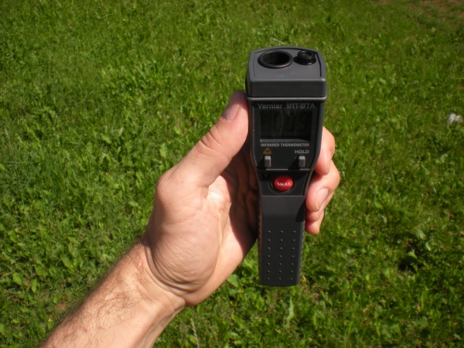
Figure 1: Measuring LWIR temperature of the zenith sky using infrared thermometer.

Illuminance and albedo measurements
Q4: How dark is any area? How bright?
Any area might appear dark, when illuminated much less than the surroundings. Or it may appear bright, when it reflects the light source, like the Sun, into our eyes – even if it is rather black. Various surfaces might be described as white. When put side by side, they may differ quite a lot. Scientifically, whiteness is called albedo. It is a number ranging from 0 to 1, saying what proportion of incident light or another radiation is returned by the surface back away from it. Values of whiteness are important for indoor lighting. It may concern also the whole solar radiation, including invisible components; in such a case, energy flux quantities are to be employed. Solar, not just visible, albedo is the quantity from which the shortwave radiant heat flux absorbed by the Earth can be computed.
Visual albedo of a horizontal terrain is easy to measure with a luxmeter. The sensor is held in a stretched arm, some 0.2 m above the ground, turned down. The other reading is taken when it turned to the sky. The ratio of these two values, that's the visual, photopic albedo, as luxmeters try to mimick the spectral sensitivity of our daytime vision.
The reading taken toward the ground represents the total light sent upwards by it, if the sensor is “lambertian” – the signal recorded by it corresponds really to the illuminance of its front plane, that is, to the integral over 2π sr space angle of flux density multiplied by cosine of the angle of incidence. Real luxmeters always try to approximate this property. You can check whether it really holds. Point the sensor to a dominant light source, like the Sun, record the reading (should be a tenth of a megalux for Sun high in the sky) and then another reading with a small shadow covering just the sensor. The difference is direct sunlight. Then attach the sensor to a long thin board, so that its entrance plane (or pupil) is parallel to the board. Point the board almost to the Sun, but so that its shadow cast on a perpendicular plane is ten times or five times shorter than its length. The plane catching the board shadow can be a ruler or a cardboard with the corresponding lengths marked. Again, two readings should be taken, one with a small shadow cast onto the sensor. A lambertian detector should show that direct sunlight illuminance of its entrance pupil is ten times or five times lower than previously.
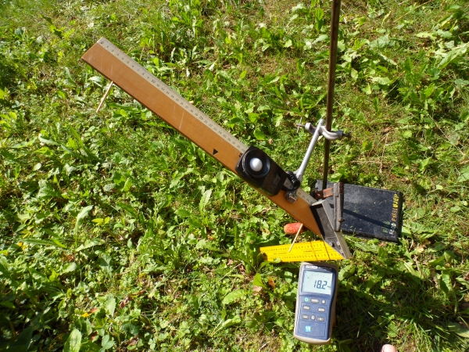
Figure 2: Verifying lambertian (cosine) sensitivity of a luxmeter sensor.
In reality, even with a lambertian detector, it may be not easy to measure the whole outgoing light flux from a selected material, if the size of its surface is not large enough, so that it would occupy most of 2 π sr space angle toward which the sensor points. Of course, the space angle occupied by the inspected surface may be easily increased by moving the sensor closer to it. On the other side, the space angle occupied by the sensor's shade increases too. The shade makes less difference, if most of the illumination comes obliquely, what is often the case. But even if the sun would shine almost perpendicularly to the measured surface, the shadow cast by a sensor hold twice its diameter from the surface, occupies but 0.2 sr, just over 6 % of the integral of cosine of angle of incidence over the whole 2 π sr, which amounts to π sr. And what's the influence of the non-infinite radius of the specimen? If the radius would be five times its distance from the sensor, then just the remaining annulus, thick just 0.2 rad, would be missing, what corresponds to a loss of some 5 % of signal. No problem, if the area surrounding the specimen is not much different from the specimen itself, that is, if its luminance is similar. If it differs a lot, an estimate can be made regarding its influence, similarly to an estimate of the influence of the sensor shadow.
A graph below should be of enough help for such considerations.
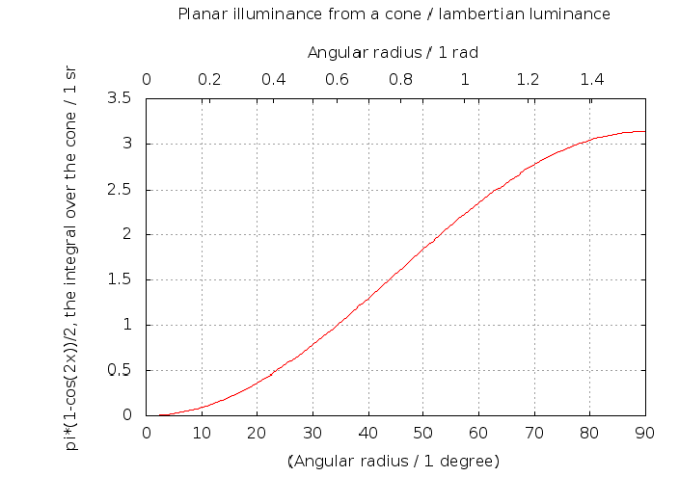
Figure 3: Effective space angle from which a lambertian sensor gets its signal, as a function of an angular radius of a cone from which the radiation is collected. The first and the last ten degrees contribute very little.
Albedo is a bit dependent on the prevailing direction of the incoming light, so it changes a bit with varying height of the sun in the clear sky. Most surfaces reflect more light when illuminated almost tangentially. Compare, e.g,, river, asphalt, grass...

A more broadband solar albedo
Q5: How different may such a solar albedo be from a visual albedo?
Sun warms the Earth surface during the day. Its radiant heat is mostly absorbed by seas and continents. The other part is returned back upwards through the atmosphere. The full solar albedo, “non-absorbed radiative energy flux / incoming radiative energy flux”, is an integral parameter describing the concerned surface. For the Earth globe as a whole, it amounts to 1/3, mostly due to clouds, which are always rather white from above. Continents and oceans without snow are much darker.
How dark? It can be estimated visually. More accurately, it can be quantified by instruments analogous to luxmeters, differing from them mostly by capturing even the infrared part of solar radiation – wavelengths longer then those of red light. Most surfaces are similar in their visual and more broadband solar properties.
However, vegetation is not... it absorbs lot of visible radiation – light, but several times less of complete solar radiation. Thanks to that, it does not heat up too much during the day, in spite of absorbing a lot of light for photosyntesis! Example: solar_up/solar_down = 1/2.5, visual_up/visual_down = 1/14 for grass at one of the author's garden...
For observing under varying cloud conditions, we have implemented a setting using both instruments simultaneously. This way the upper sensor can be compared with the bottom one properly. Two luxmetres could be used, we employed a luxmeter and a PV solarmeter.
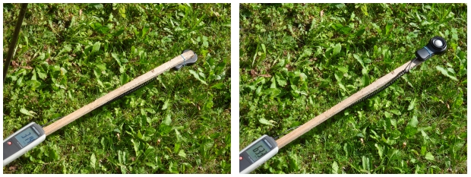
Figure 4: Measuring solar albedo of grass using PV solarmeter. The sensor placed 30 cm above ground detects radiation reflected by grass surface (left) and incident solar radiation (right). The same procedure is applied to measure visual albedo using luxmeter.

Cooling and warming measurements
Q6: Many scientists recommend to paint roofs white to reduce global warming. Why?
The answer lies in understanding the balance of radiation entering and leaving the earth’s atmosphere. During the daylight white surface rejects more of the incoming radiation from the sun and also emits efficiently longwave infrared radiation when it gets hot. This emission causes the white surface to be a lot cooler than an aluminium surface when in the sunlight – aluminium has low emittance and radiates much less at the same temperature. It warms the air a lot, whereas a non-metal surface sends the heat as radiation high into the sky, partly it proceeds to the universe directly. Painting any roof white when living in a hot, sunny climate brings comfort locally, and, even if very little, diminishes the existing energy disbalance of the Earth.
On the contrary, if something is to remain warm at night, its radiative cooling can be prevented by an aluminized envelope. Such foils became a common aid for rescuing injured people, so it suffices just to remember them to the students.
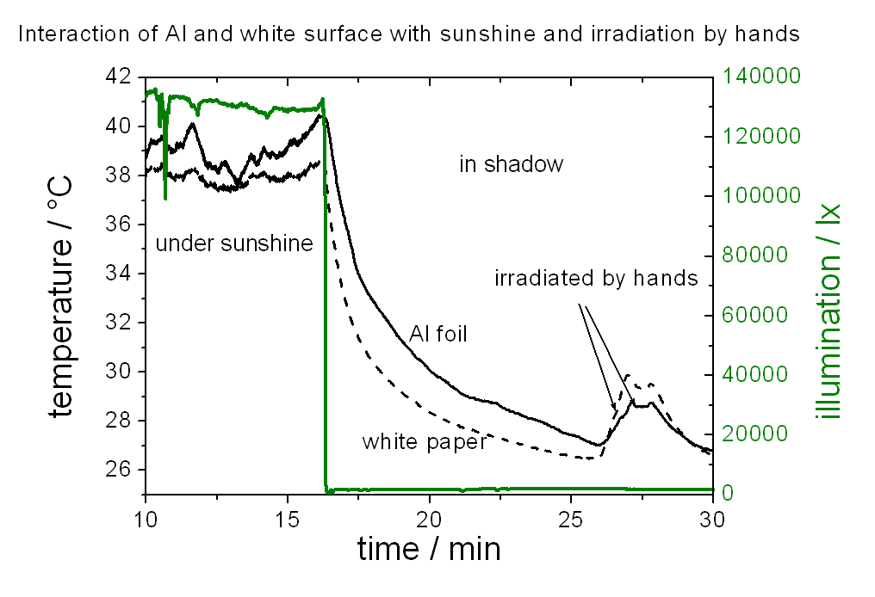
Figure 5. White paper and an aluminium sheet cooling and heating
The graph above shows an example of very simple measurement – having temperature sensors below a sheet of white paper and an aluminium foil. The right axis gives a proxy for sunlight; real illuminance was below 110 klx very probably, as any values over this limit can be just very temporary, when some white clouds redistribute radiation from shadowed to sunlit areas. A better setup would be, e.g., to use thicker aluminium sheets, with differently treated surfaces – either a fresh Al-foil and or paper glued on them, and sensors attached to the well conducting metal.

Conclusions and discussion
Above, we gave just some hints on investigating very common processes and quantities, and we did not treat the metrological jungle of radiometry and photometry in detail. We are sure that teachers and students will find further approaches to such activities and that when performing analogous measurements, mastering the terminology of these disciplines will be interesting and possible for them. The future science teachers will be evaluated on the bases of their observations, experimental design, communication, and reasoning. We intend to compare this new approach for laboratory work with older, more conventional classroom teaching over relatively short periods of time.
Another observational and experimental themes will be measurement of carbon dioxide concentrations and their changes due to daylight-driven photosyntesis and all-day respiration, greenhouse effect demonstration, demonstration of pyrolysis and production of biochar with its subsequent application, measurement of atmospheric aerosols and cloud properties, measurement of water content of the atmosphere and the pace of evaporation.
Commented images from the activities mentioned above, as well as the presentation from the conference are available at the site http://amper.ped.muni.cz/gw/activities.

References
Dewey, J. (2012, November 4). In Wikipedia, the Free Encyclopedia. Retrieved from http://en.wikipedia.org/w/index.php?title=John_Dewey&oldid=520984423
Hollan, J. (2009). Pasivní domy a zářivé toky energie. Retrieved from http://amper.ped.muni.cz/pasiv/windows/JH_disertace/
Mims, F. M., Chambers, L. H., Brooks, D. R. (2011). Measuring Total Column Water Vapor by Pointing an Infrared Thermometer at the Sky, Bulletin of the American Meteorological Society, 92, 10, 1311-1320, doi:10.1175/2011BAMS3215.1, Retrieved from http://journals.ametsoc.org/doi/pdf/10.1175/2011BAMS3215.1

