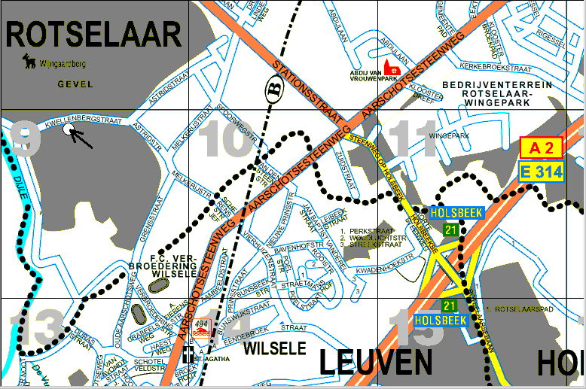

Coming from Brussels: take the E40 direction Luik (Liège).
Between the exit number 22 and 23 you can get on the E314.
On the E314 (see map above) you take exit number 21 to Rotselaar.
There you come on the Holsbeekse Steenweg, you cross the Aarschotsesteenweg and continue on the Stationstraat. You will pass trainrails, and then you will see at your left side the DANONE factory. Behind the DANONE you take the first street to the left (should be the Melkerijstraat but I think there’s a new street that is not on the map). Anyway, you get into the Astridstraat that becomes the Kwellenbergstraat and then you will see the house on the lift side….

Coming from the Netherlands: take the E314 to Leuven/Brussels.
You cross the border in Geleen. Then you also take exit number 21 to Rotselaar.
See further description above.

