Thermal improvement of windows
by low-emissivity blinds
Jan Hollan, TU Brno, Fac. of Civil Engineering, Institute of technology of building materials and components;
Yvonna Gailly, Ecological Institute Veronica, Panská 9, 602 00 Brno, Czech Republic, yvonna.gailly at ecn.cz

Abstract
Low-e blinds can improve old windows to a 2x or even 4x better standard.
Including sophisticated low-e blinds into new windows is a complication, which is worth it. Large windows can be used without any problems with overheating or cold drafts, as they can be improved as needed.
Thermography is being shown as an easy method to measure insulating properties in situ.
See more info at http://www.veronica.cz/passiv.

Introduction
Nighttime insulating properties of standard passive-house windows can hardly be much improved by common blinds. But there is a possibility to use low-e blinds, with aluminium surfaces.
The only need is to prevent spoiling the aluminium by a paint. Any paint has emissivity near to 0.9, a clean aluminium below 0.10. By using aluminium covered with just a natural oxide layer, the radiative transfer can be reduced 10x.

Rough considerations
Let’s consider a tight layer with an emissivity of 0.1 put between two uncoated glasses. The radiation transfer is reduced
from the usual 4 W/m²K to about 0.5 W/m²K,
making it small with respect to the transfer by air (about 2 W/m²K).
An air-filled gap between two ordinary glasses has a thermal resistance of some 0.17 m²K/W. Dividing the gap by an aluminium layer means creating two gaps with conductivities of about 2.5 W/m²K each, i.e., getting a thermal resistance glass-to-glass of about 0.8 m²K/W.
Installation of such a layer into an old double window means
improving its U-value from some 2.7 W/m²K to some 1 W/m²K.

Outer shades are often made from aluminium – but from a painted one. When tight, they add just 0.17 m²K/W to the thermal resistance of window at most. If an outer shade would have a clean Al inner surface, it could add up to 0.4 m²K/W. a value interesting even for passive-house windows.

Verification
These values depend on the air-tightness. There exist blinds which are not tight at all. Assessing the true benefits of them is possible just through measurement. This can be done by thermography. Seeing is believing.
A flux through the window is roughly proportional to the temperature difference of a window pane and an unheated/uncooled reference piece of glass, being thermally insulated from the window and facing the same space. Adjacent windows have been compared this way.
Direct assessment of thermal flux per one square metre of the glass has been made using a heated reference glass, thermally compensated from behind.

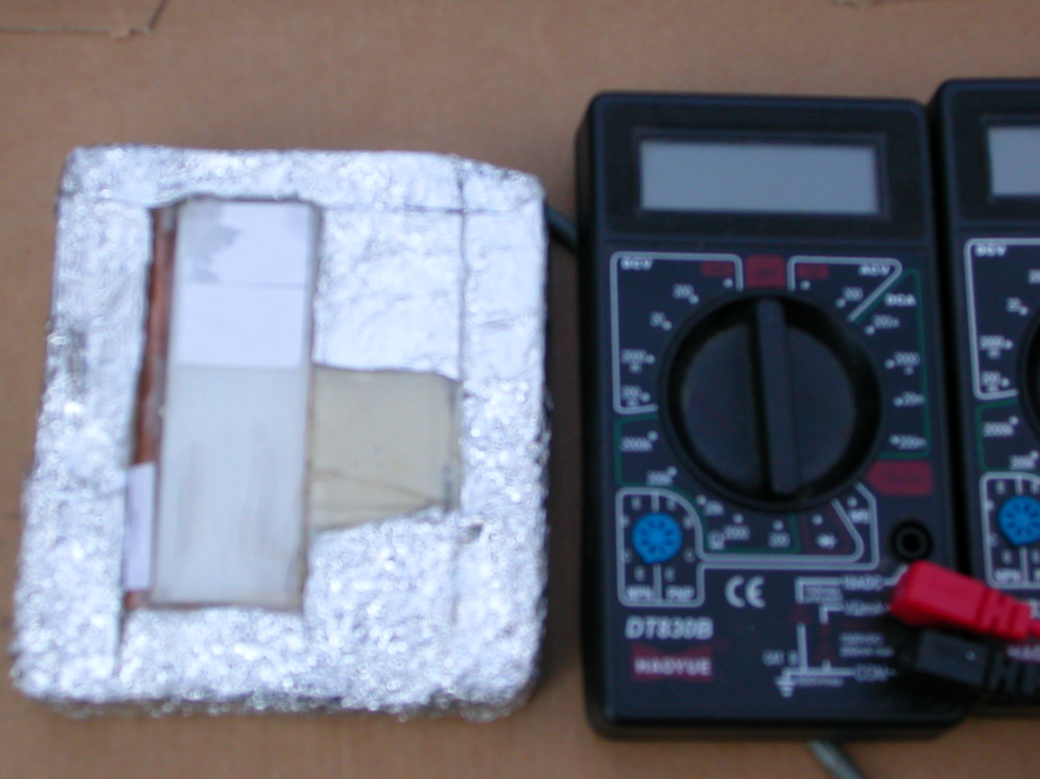
Black temperatures. Unheated reference piece of glass at left, the heated one at right, standing on a window grate.

The window glass is 3 K warmer than an unheated glass (case of a low-e venetian blind, U= 2.3 W/m²K).

Roller shade
A roller shade has been installed into a traditional double window. Straight wooden sticks (of about 1.5 cm thickness) were mounted to the sides of the window box, at the interior side from the foil. A cold air in the exterior-side cavity pressed the foil to them making the shade tight. The outcome: the Al-covered foil improved the whole window more than twice, to value close to “U 1.0”. A nice feature is the remaining visual transparency of 3 %.
A second foil can be added. With a sacrifice that just 0.1 % of light will pass, we can get a window with U close to 0.6 at night (the daytime properties are good enough).

Left: black temperatures at nigh. An unheated pane at left (over an old sundial). Cold heavens reflects in the glass; the polystyrene insulation behind represents the equilibrium temperature better. Both shades are pulled down. Inner-outer temperature difference is 20 K, the window is 1.5 K over the unheated reference surface. Windstill weather (inner temperature drop was almost the same).
U results at about 0.6.

Right: detail of the first shade being pulled down. A second stick serves for another shade.

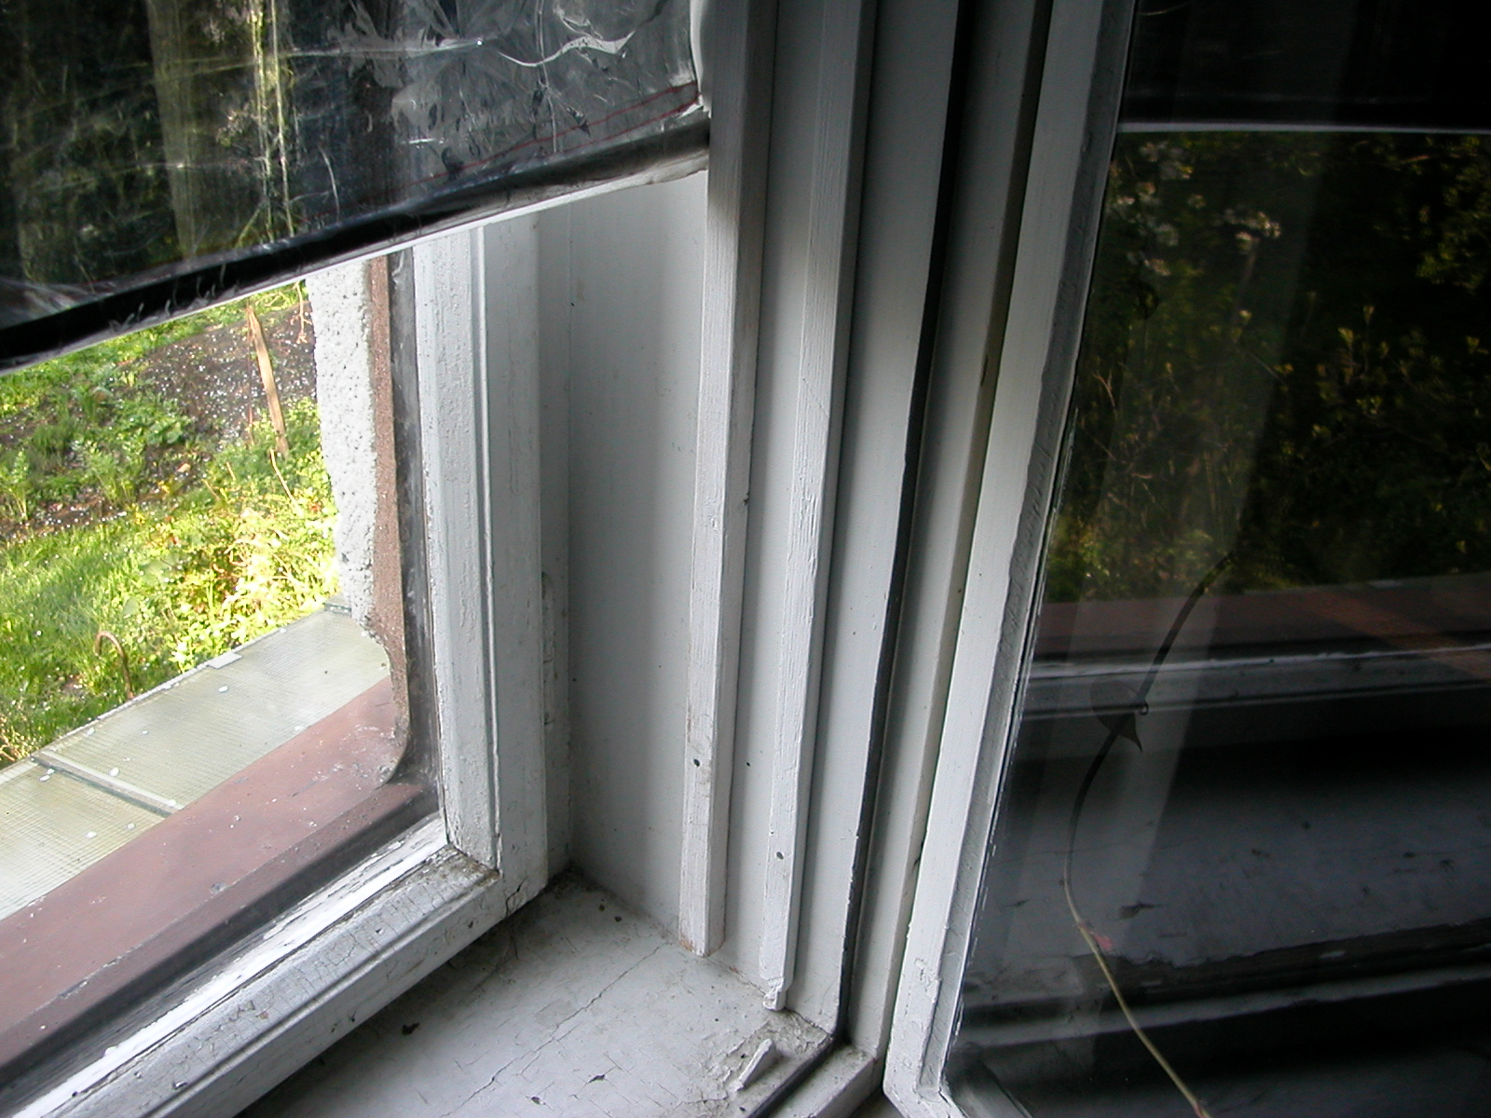
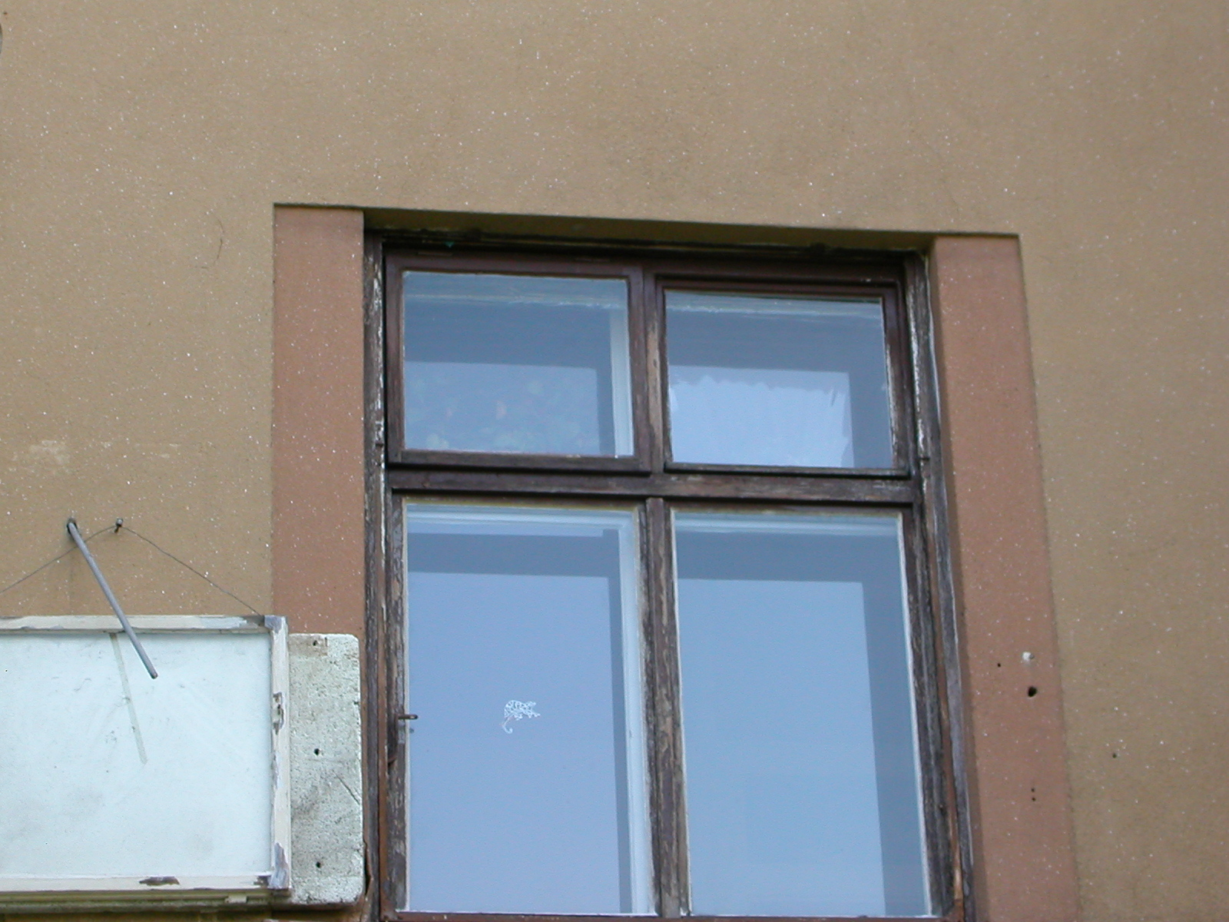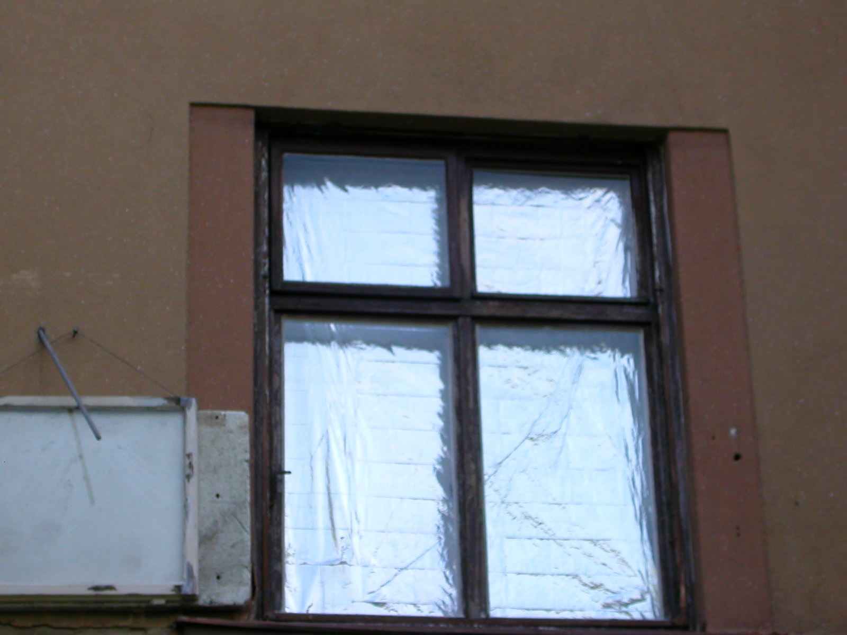

Visible radiation, without and with blind. The blind reflects so much light that the surroundings seems dark.

An unheated comparison pane at left is hanged over an sundial.

Venetian blind
We have installed such a blind in a window with a broad gap. The spoiled low-e property of the aluminium was restored by gluing a new Al foil onto the strips.
Surprisingly, the benefit of the closed blind at night was rather small. The insulation properties of the window improved not even by one third. Thermal flux through the window corresponded to U of about 2.3. Seems that convection inside the window became a lot stronger. Nevertheless, even a mild improvement like that is of some interest.

A really novel standard
Our recommendation of an alternative passive-house window:
- a low-iron glass,
- a generous air gap with two roller blinds,
- and the best available low-e double pane with a coated surface at the interior glass.
Solar gains can reach 0.7, night U-value 0.4.
For roof windows, this is the only solution which can reach the passive house limit and prevent overheating reliably.
(Japanese vacuum glazings might be an alternative for the inner double pane. In a tilted position or under extremely cold weather, there is no worsening of their properties due to convection. In old window frames, their thickness of just 6 mm is an advantage.)
For the optimal performance in all circumstances, the blinds are to be driven by an automated system – an option which is not common yet.

– with no apparent problems
There exists at least one German manufacturer, who makes electrically driven roller blinds (even for horizontal windows) as solar shading. It mentions that thermal losses are diminished a bit, but does not optimise the system for that. Just two changes are needed, however:
- positioning the blind at least 1.5 cm from the nearest glass
- caring about its emissivity at both sides (to be below 0.1)
As the manufacturer offers blinds even in argon-filled units, it can be assumed they are reliable and of very long life.

Why do we care
Veronica is going to build a passive office, lecture hall and apartment house as a “Centre for Sustainable Rural Development” at the eastern border of Czech Republic. Due to strict zoning requirements, the office is to be under a saddle roof. Developing true passive-standard roof windows is a necessity here (with the resulting need to have a way of clearing snow from them in winter). Integrated Al-covered blinds are a must to maintain comfortable summer conditions.

Passive-standard strawbale insulation

Another topic the Ecological Institute Veronica has to solve for this project, is the improvement of strawbale insulation to approach the needed U close to 0.1.
Our old suspicion, that convection inside such a very porous fibre insulation might compromise its properties a lot, appeared to be really the case. In freezing temperatures, U values of standard bale walls is about 0.2.
The problem is similar to insulation by windows. The key is to keep “Nusselt number” not much over 1 (this number, Nu, is the ratio of total thermal flux to that without convection).
With additional blinds inside a window cavity, convection contribution is diminished a lot, as the temperature drop over each cavity is smaller than over the undivided cavity (an advantage which is for simplicity not discussed above).
The solution for any very permeable fibrous insulation material is analogous: preventing the existence of the single convection cell by dividing the cavity by (almost) impermeable barriers.
It appears that for all extremely porous insulation materials, it is sufficient to divide the cavity by vertical barriers into thirds.
For blown infills, it’s easily done by e.g. cardboards.
For strawbales, we develop an injection method, which will create two gypsum boards inside a bale. It seems promising, keeping the cost of strawbale insulation still well below the commercial insulations. For both common orientations of standard bales, U below 0.12 can be achieved.
Using two thick clay or clay-gypsum barriers, there is an option to get a novel loadbearing (and extremely fire-resistant) structure.
See more at http://amper.ped.muni.cz/strawbale.

