The radiative role of clouds – which ones warm and which ones cool the Earth
Clouds are akin to greenhouse gases in some respect: they absorb solar radiation (which is, due to Sun's surface temperature of some 6000 K, mostly shortwave, below 3 μm) much less than longwave infrared radiation of the Earth (above 3 μm, up to tenths of a millimetre). They are “spectrally selective”. But unlike greenhouse gases, they affect solar radiation by altering its direction, they disperse it. (Trace gases in the atmosphere contribute negligibly to dispersion of sunshine, even major constituents, nitrogen and oxygen disperse but some 8 % of rays going right down.) While greenhouse gases are clear, transparent for solar radiation, clouds are white for it. Still, some cloud types contribute to the greenhouse effect. (For an overview of cloud parameters, see e.g. http://isccp.giss.nasa.gov/cloudtypes.html.)
Most the of sunshine dispersed in clouds goes further forwards at first, for water droplets it is even more so (Laven) than for icy crystals forming the high clouds, cirrus (Shcherbakov et al.). But even though, if the cloud is not rather thin, then after the radiation is scattered many times, it mostly returns back upwards (is “reflected”), just a smaller fraction makes its way down to the ground.. Consequently, a thick cloud is brighter, whiter from above than from below, i.e., it has a larger luminance viewed from above.
A layer of a fresh snow on a roof window may be an analogy of such a not-thin cloud. Cirrus clouds are, however, mostly thin, and reflected sunshine is fainter than that which made its way trough, or even than its unscattered form, which offers a sharp view of the Sun. Probability distribution functions of solar optical depth τ (measure of the proportion of radiation which does not pass through unscattered, for τ=3, just 1/e³ = 1/20 passes, for τ=4 it is 2.72× less, etc.) of low (droplets) and high (icy – cirrus and cirrostratus) clouds is shown below (Jin et al.); the graph does not illustrate how much light passes through in scattered form:
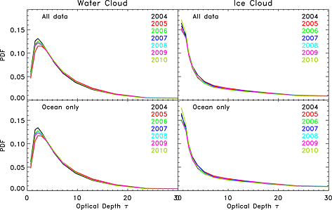
Apart from scattering, clouds absorb the infrared part of solar radiation slightly, being heated this way.
For longwave infrared radiation emitted by the surface and by greenhouse gases, clouds are not white at all. They absorb that radiation very strongly, ice crystals are even more efficient than water droplets. For such wavelengths over 3 μm the particles are as if they were from black ink. Just thin clouds let some of LW (LongWave) infrared through, thick ones don't. A tiny amount of that radiation is, by multiple scattering, reflected back, but even from thick clouds it amounts to 4 % at most, so we may say that thick clouds are pitch black for terrestrial and atmospheric radiation. Even thin cirrus clouds absorb most of the LW infrared – and then radiate their own infrared, according to their temperature.
So, if a layer of greenhouse gases behaves somewhat like a glass pane, clouds behave like a frosted glass pane they just reflect less LW infrared and may let through some of it, which glass never does.
For considering the effect of clouds to Earth radiation budget, let's start with the situation at night, with no sunlight (no shortwave radiation). Then, all clouds but those sitting atop an inversion over the ground, have a warming influence, as they radiate upward less than the ground or sea, being colder than the Earth surface. “They shield the surface from the cold Universe.” But not all clouds are equally potent in this respect. Those which are close to the surface have temperatures not much differing from ground or sea, so they radiate still quite a lot. The cirrus and cirrostratus clouds, however, are very cool, and their presence reduces radiation to the outer space very much.
With sunlight, such warming influence is mostly counterbalanced by a cooling effect, as the clouds reflect sunshine away from the Earth (only if the ground is snow-covered, the albedo of that region does not increase due to clouds). The low-lying clouds reflect sunshine rather strongly, and, consequently, their cooling influence much prevails during the day, and even in the sum of day and night hours, lest for polar nights in Arctic or Antarktic. Cirrus clouds, if not very thick, reflect sunshine much less, so the warming influence wins.
Simply said, more cirrus clouds, if not very thick, means stronger greenhouse effect. More cumulus, stratocumulus or stratus clouds would cool the Earth. However, as it appears, global warming does reduce their amount slightly. If higher temperatures lead to less low-lying clouds, it is a (slight) positive feedback contributing to further global warming, see https://skepticalscience.com/clouds-negative-feedback-basic.htm.

More detail
The real difference brought by a cloud layer is blocking the radiation in the “spectral window” 8 μm to 13 μm range, which is little absorbed by greenhouse gases and which, consequently, can escape from the Earth surface directly to the Universe. In most another wavelengths, the longwave infrared radiation escaping from the Earth is emitted by air in heights where cirrus clouds appear, or even by air above cirrus layers, which are very cold. Cirrus clouds block also radiation in the second window, which exists in air with very small vapour content, what is the case for any air at temperatures deep below zero Celsius, at 17 μm to 25 μm range.
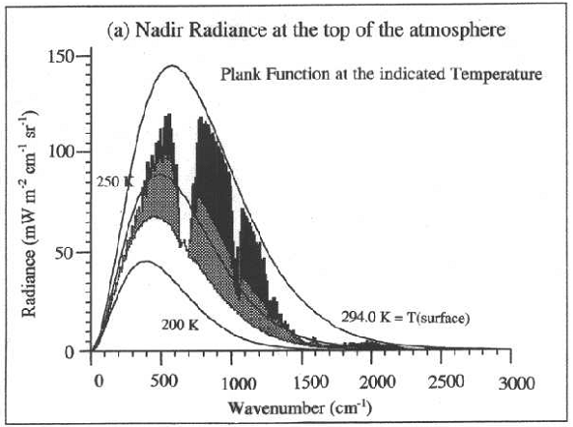
The above figure, taken from chapter 10 of Ellingson & Takara, shows a typical case of summer middle latitudes, with surface having 21 ºC. Smooth curves are Planck spectral radiances for given absolute temperatures (at the y-axis, the correct unit is mW m⁻² cm sr⁻⁻², “cm” cannot have an exponent -1; then the integral of the area under the curve gives really a radiance). The real spectrum of the outgoing radiation in absence of clouds is the wiggly top of the black area – just within 830 to 1250 cm⁻¹ (that corresponds to an “atmospheric window” from 8 μm to 13 μm), surface is “visible” form the Universe, apart from a band at 10 μm, where ozone absorbs. A cloud layer at 4 km height would reduce the outgoing radiation to the top of the grey area. And a completely absorbing cloud layer at 11 km (a cirrus which is not very thin) would bring it to the bottom of the grey area, close to the Planck curve corresponding to some 230 K, −40 ºC.

How to visualise it
The reason I wrote the lengthy explanation was to understand the issue myself and propose an improved version of the figure http://skepticalscience.com/graphics.php?g=9
If we are interested in global heat budget, just the change in fluxes escaping from the Earth are important. The red arrows going from the clouds down should be abandoned. There should be 3 upward-going arrows, representing just the radiation within the atmospheric spectral window. One should go from the ground and between the clouds, the other two from the clouds. The grounded one should represent 120 W/m² as for a 15 C body. the low cloud should sit really low, having top like if below 2 km, 10 K colder than the ground, and emit 100 W/m², the high cloud should be really high, flat and thin (no cumulus), say at 8 km, 50 K colder than the ground, radiating 45 W/m².
The texts on the clouds might be:
High clouds radiate much less, being cold
Low clouds reflect more and radiate still a lot
And the title of the scheme should be perhaps (it shows no feedback):
High thin clouds have a warming influence
or, similar to the original title:
Example of cloud warming/cooling effects
A quantitative example see p. 355-356 of Principles of Planetary Climate (Pierrehumbert).

References
Ellingson, Robert G., a Ezra E. Takara. “Longwave Radiative Transfer in Inhomogeneous Cloud Layers”. 3D Radiative Transfer in Cloudy Atmospheres. 2005. 487–519. . <http://www.met.fsu.edu/people/ellingson/downloads/bookCh10.pdf>.
Jin, Zhonghai et al. “An Efficient and Effective Method to Simulate the Earth Spectral Reflectance over Large Temporal and Spatial Scales”. Geophysical Research Letters 40.2 (2013) : 374–379. 12 bře. 2013. <http://onlinelibrary.wiley.com/doi/10.1002/grl.50116/abstract>.
Laven, Philip. “Mie scattering”. <http://www.philiplaven.com/p2.html>.
Pierrehumbert, Raymond T. Principles of planetary climate. Cambridge University Press, 2010. . <http://geosci.uchicago.edu/~rtp1/PrinciplesPlanetaryClimate/index.html>.
Shcherbakov, Valery et al. “Light Scattering by Single Natural Ice Crystals”. Journal of the Atmospheric Sciences 63.5 (2006) : 1513–1525. <http://journals.ametsoc.org/doi/abs/10.1175/JAS3690.1>.
Draft text by J. Hollan, CzechGlobe, March 13, 2013

