Climate Change Education for Physics Teachers
Tomáš Miléř, Jan Hollan, Jindřiška Svobodová
Faculty of Education, Masaryk University, Czech Republic
Abstract (last change: 2014-06-12, published www.icpe2013.org/proceedings, p. 561-569)
Climate change science is a multidisciplinary field. Many important functions of the climate system are domain of Climate physics. We claim, that physics teachers should have good understanding of basic principles of climate physics, e.g. greenhouse effect and causes of sea level rise, in order to transmit the knowledge towards their pupils. Dozens of studies have shown that people (mostly students or pupils) confuse greenhouse effect with ozone hole. To investigate the roots of misconceptions, we interviewed students at Masaryk University, Faculty of Education, who suppose to become physics teachers. We found their understanding of greenhouse effect is poor, ozone holes are out of their scope. Our results are being utilized to design a university course using laboratory and outdoor experiments and measurements, explaining vital concepts thoroughly – some examples are here too.
Keywords: university education, physics, climate change, greenhouse effect

The importance of Climate Physics
Climate change theme is present in media and politics quite a lot. However, even people with good science education may not really understand the mechanism controlling the Earth temperature – the greenhouse effect. And if they don't, the very reason why the enthalpy (and, therefore temperature) of the Earth is rising now, is obscure to them, they can but believe what some experts are saying – or not believe them.
The primary group who should understand, are physics teachers of course. Then the understanding may spread to their colleagues and pupils, and, hopefully, to most people at last. Being sure why the Earth is warming, may enhance their motivation to slow it down, stop it or even reverse it.
We won't repeat here, why is climate change caused by Earth radiative imbalance so extremely serious for the mankind. Excellent review articles, reports and books exist on this topic. If we should recommend a single book describing how the state of our planet has changed already and what should be our strategies for the future, it might be [1] (Czech remarks to its Czech version are at [2]). A recent appeal by prominent scientists is [3], two reports for the World Bank are [4] and [5].
Climate physics is the tool for quantitative and qualitative understanding to global warming and climate change. The most basic parts of it can be somehow learned even on elementary schools. We shall show some hints how to achieve it.
Pupils from 10 years on should be aware of importance of greenhouse gases for Earth's climate, of the reality of Global climate disruption and of Adaptation (a large one, transformational [6]) and Mitigation, which should go hand-in-hand.
For students at the beginning of university studies, climate change education is an opportunity to integrate many disciplines [7].

An obstacle to understanding: misconceptions
Several false conceptions regarding climate change are reported in [8], as:
“One of the most popular persistent misconceptions is that the ozone hole plays a major role in global warming (e.g., [9]).”
“More than half of the students in a Swedish study believed that the greenhouse effect is only a human-induced phenomenon. They did not distinguish between the natural greenhouse effect necessary for life on Earth and its human enhancement [10].”
Our research started with a question: What misconceptions about greenhouse effect do pre-service physics teachers have?
We have interviewed six PhD students of didactics of physics, meetings lasted on average 20 min. Students were informed in advance only about the topic of interview – Greenhouse Effect. They were not trained or prepared for it. Interviews were conduced following a structured set of 17 questions or tasks, were recorded and analysed.

The tasks and questions
Four tasks/questions were based on such pictures, which are rather typical in texts or web pages which try to explain the phenomenon. All of them are of no real help, or even worse, they are misleading. But we did not comment on those pictures when showing them to the post-graduate students. Nor did we comment on their answers during the interview and even after the interview. We just thanked them for devoting their time and expressing their own thoughts to us.
1. Use the following picture to explain the greenhouse effect:
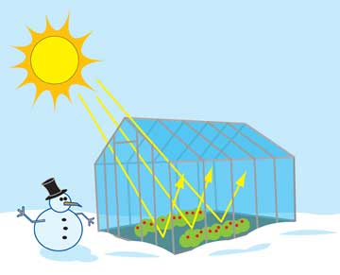
Figure 1: a (useless) illustration of a greenhouse
2. Use the following picture to explain the greenhouse effect in the Earth's atmosphere:
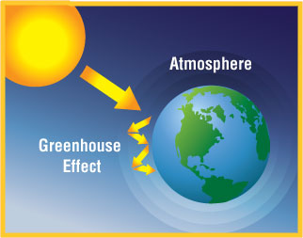
Figure 2: a (misleading) illustration of radiative fluxes over Earth
3. What differences can you see for those two cases?
4. How does foil greenhouse work?
5. Estimate an average surface temperature of the Earth.
6. Estimate an average surface temperature of the Earth without atmosphere.
7. What are the most significant greenhouse gases in the Earth's atmosphere?
8. Where are the greenhouse gases in the Earth's atmosphere located?
9. When concentration of atmospheric greenhouse gases increases, what happens to the temperature of (a) Earth's surface, (b) stratosphere?
10. What you think the picture below represents?

Figure 3: guess what...
11. Use the following picture to explain the function of ozone layer:
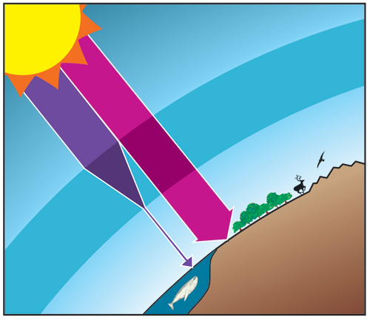
Figure 4: UV and longer wavelengths, for sure, but... UV makes far less then half of solar irradiance
12. Where in the atmosphere is ozone located?
13. What is the cause of ozone layer depletion?
14. Where in the atmosphere are ozone holes located?
15. Why do ozone holes form above poles?
16. Can global warming somehow contribute to depletion of ozone layer? (How?)
17. Can depletion of ozone layer somehow contribute to global warming? (How?)

Findings

House envelope as an air flow barrier
The students guessed somehow that glass blocks longwave infrared radiation, in spite of the pictures served to tasks 1 and 2 giving no hint for that. However, they were unable to explain why even under foil-greenhouse, the temperature is higher then outside, in spite of foil being non-opaque for longwave infrared. To put it otherwise, they might not realize why the inside of the house is “naturally” kept warmer than outside even in those mild months when no heating is used. Or, in very hot days, a house can be kept a lot colder than outside air. Just the air flow is to be either allowed or blocked by using windows and doors cleverly... They would surely come to the conclusion that (green)house envelope primary function is separating the air inside and outside, if it would be discussed with them. So it seems they did not exercised such thinking during their lives, in spite of being graduates in physics teaching.
This difference between a greenhouse and the Earth surrounded by its atmosphere, was not identified by the students (questions 3 and 4).

Hesitation whether Earth without atmosphere would be warmer or cooler
The students estimated the average Earth surface temperature well. But just one student, after thinking aloud for a while, came to the conclusion that without any atmosphere, Earth would be a lot cooler and gave a value (probably remembered it) that it would get to some −18 ºC. Another speculated mostly, that without atmosphere, there would me more sunshine and therefore the Earth surface would be warmer. Evidently, the pair of words “greenhouse effect” was just something that they hear often, but have little idea what it is in reality and how huge it is. Probably, they connect it, like the Swedish respondents in [10], just with the recent alteration of atmospheric composition due to anthropogenic emissions.

No misconception of greenhouse gases being located somewhere in the height
Names of several greenhouse gases and the fact that apart from water vapour they are well mixed in the atmosphere were known to all students. However, the opposite temperature change in troposphere and stratosphere due to their rising concentration was not known to them.
Common conclusion of similar studies that people believe that greenhouse gases are located in a single layer (as many misleading illustrations show, trying to “simplify”), was not found here. This may be due to the fact that respondents were graduates in physics. Even if they had been offered a single layer model to explain greenhouse effect, they did not really believe it is so in case of atmosphere (we asked them explicitly).

No idea about location of ozone holes etc. (question 10 to 16)
All students guessed that the picture at question 10 may illustrate the ozone hole. They knew ozone is mostly high in the atmosphere, is absorbing UV radiation and its depletion was due to halocarbons.
However, they had no idea “ozone holes” are local minima over Earth poles. Therefore the mechanism of its enhanced destruction, needing surface of solid phase (ice crystals) to mobilize chlorine or bromine compounds was also alien to them. It seems that the topic of ozone depletion is so old already, that the students never encountered or remembered any explanation what happens in reality. The holes were discussed in media when they were discovered, before the halocarbon emissions were greatly reduced thanks to Montreal protocol.
No wonder they did not know the current cause of non-healing Arctic ozone hole – falling temperature of stratosphere, leading to larger amounts of ice crystals there, causing more ozone depletion even without rising amounts of Cl and Br atoms.

Confirmed conception that ozone hole allows more solar radiation to penetrate the atmosphere and heat Earth's surface
Although in principle this idea is right, the heating effect due to diminished shortwave absorption is small and the cooling effect due to diminished longwave absorption and emission probably prevails [11]. Influence of changes in stratospheric ozone is, in any case, an order of magnitude lower than the total anthropogenic influence on Earth's radiative balance. In fact, interviewees have probably never investigated the problem before – they fabricated this (mis)conception during the interview. This idea is connected with the mostly wrong answer to q. 6 – atmosphere being considered just like a sunshine blocking medium.

Our hints how to teach these topics

An illustration of GH which might help
Greenhouse effect is... a process, in which the Earth surface is irradiated not only by Sun, but by the atmosphere too. Spectral selectivity of the air (shortwave radiation goes mostly through, longwave is absorbed and emitted) is the key for it.
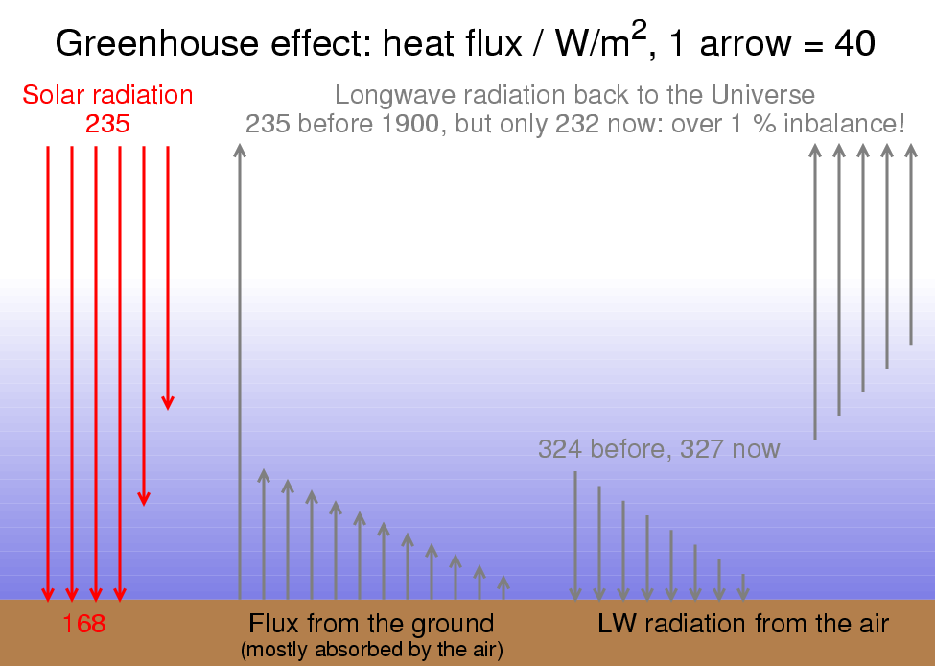
Figure 5: The huge invisible fluxes of longwave radiation near the ground are much larger than solar input; the radiative imbalance of 3 W/m² would hold for a non-real case when no cooling aerosols would be produced by mankind and the air would be no warmer
The longwave (>3 μm) infrared flux down to the Earth is almost twice larger than solar radiation, taken as an average over the globe. It is really huge. A slight increase of longwave opacity due to higher concentration of greenhouse gases means a serious change of those longwave fluxes, to the surface and to the space. Visualizing the greenhouse effect seems to be not easy, as we did not find any illustration which would help – we had to make our own. A larger illustration with a lot of text is available (in Czech only, will have an English version) at the end of [12].

If greenhouse gases would cease to exist, the temperature would drop by 100 K
The usual answer the Earth surface would be some 33 K cooler, is a misconception which is universal indeed. Such a value would hold if the Earth would retain its albedo. With the existence of water, this is of course impossible. The Earth would freeze, continents would be covered by snow, the oceans by ice and snow too. It would be much much cooler than “snowball Earth” that really existed in some geological periods in distant past. The temperature would drop by a good 100 K from our ~288 K!
How can we say? This is the equilibrium temperature / 1 K, provided the albedo stays the same – Earth absolute temperature would be such that it would radiate the same amount it absorbs from the Sun:
4 π ρ T ⁴ = π ∙ (1 − albedo) ∙ solar flux density
((0.7 ∙ 1361 / 4) / 5.67e-8)^{1/4} ~ 255
(the numbers represent the current Earth absorptivity of 0.7, “solar constant” 1361 W/m² [13], factor 4 as a ratio of radiating Earth surface area (sphere) and its sun-lit cross-section (circle), and the the numeric value of Stefan-Boltzmann constant ρ).
Actually, this is also the temperature the Earth in a steady state seemed to have if observed from the space – as most of longwave radiation there comes from high in the troposphere, which is really that cool.
The snowball Earth would have a much higher albedo, say, 0.8, so the absorptivity would be just 0.2 and the temperature / 1 K would drop to
((0.2 ∙ 1361 / 4) / 5.67e-8)^{1/4} ~ 186
So, it is really some 100 K below the current surface temperature of 15 ºC!

Above troposphere, GHGs cool the air
This is difficult... One obvious reason is the troposphere radiates upwards less than before, due to its increased opacity.
The other reason is that the so-called pressure broadening of molecular spectral lines is no more present in stratosphere and higher (too few molecular encounters, enough time to radiate at the exact frequency). So the gasses absorb little of the upwelling LWIR, but still do emit at full Planck strength...
(Still larger decline of stratospheric temperature is due to stratospheric ozone depletion, leading to less solar heat being absorbed in those heights.)

What is the solar heat...
As mentioned in the caption of Fig. 4, showing the UV part of solar radiation as something very strong is very misleading. It's but a tiny part of solar radiative flux density. From the UV, visible an infrared spectral regions, most solar heat flux hitting the surface is within the visible region. The Sun warms us mostly by light! Such wrong pictures as Fig. 4 may have resulted in a blunder which can be found in an (otherwise excellent) book [14]:
“As we’ve seen before, the incoming radiation is mainly ultraviolet (UV) radiation. This UV radiation heats the Earth which causes it to re-radiate heat in the form of infrared (IR) radiation. Much of this IR radiation is trapped near Earth’s surface by the greenhouse gases that in turn re-radiate some of this back to the surface.”
It would be nice, for simplicity, if we could neglect the IR wing of solar spectrum, but we cannot. It represents a half of solar irradiance, see Figure 6.

Figure 6: The visible part of solar spectrum called light spans roughly from the pair of calcium spectral lines at the far violet end of the visible range to a terrestric O₂ molecular spectral band at its far red end. Wavelengths over 760 nm are infrared, the pair of strong Ca lines, named K and H by Fraunhofer, are at the beginning of UV range. The curve for “incl. diffuse radiation” concern a direction pointing to the Sun being at 42° of angular height, with its rays going through 1.5 more air than the vertical direction would imply, this is denoted as AM 1.5; they include radiation coming from the terrain (“light soil”) as well. See details of air+ground conditions at the source of data, http://rredc.nrel.gov/solar/spectra/am1.5/. The gnuplot script for the graph is http://amper.ped.muni.cz/gw/aktivity/graphs/sources/sol_eng.gnp; the employed axes are the proper ones for Planck curves to visualize the course of spectrum and being able to guess the integrals over various spectral ranges, as the area below the curve represents really watts per square metre in a chosen range [15].

Conclusions
Even the post-graduate students of didactic of physics miss the most basic physics of what makes the Earth habitable. No wonder, the information they may have encountered is confusing. On the other side, learning it properly should be not difficult, if good illustrations and texts would be available. Pre-service physics teachers should be provided with comprehensive course about physical background of climate change and related issues.
We developed a study material (textbook) for pre-service physics and chemistry teachers, describing also a couple of phenomena which the students should learn by observations and experiments. The textbook [12] should be available in English in 2014.

References
[1] B. McKibben, Eaarth: Making a Life on a Tough New Planet. New York: Times Books, 2010. http://www.billmckibben.com/eaarth/eaarthbook.html.
[2] J. Hollan, “Poznámky ke knize ZEEMĚ,” 02-Aug-2013. http://amper.ped.muni.cz/gw/aktivity/dale_ctete/.
[3] J. Rockström, H. J. Schellnhuber, M. J. Molina, B. Hoskins, G. Brasseur, C. Nobre, P. Schlosser, V. Ramanathan, N. Nakicenovic, Y. Sokona, L. Srivastava, and J. Morgan, “Are we heading towards 4-degrees warming? And if yes, should we be concerned?,” 16-Sep-2013. http://www.hzg.de/mw/earthleague/036338/index_0036338.html.en.
[4] T. W. Bank, “Turn down the heat : why a 4°C warmer world must be avoided,” The World Bank, 74455, Nov. 2012 http://documents.worldbank.org/curated/en/2012/11/17097815/turn-down-heat-4%C2%B0c-warmer-world-must-avoided.
[5] A. Bondeau, A. Svirejeva-Hopkins, S. Schwan, J. Schewe, B. Hare, K. Frieler, M. Rocha, M. Schaeffer, F. Piontek, R. Donner, H. J. Schellnhuber, O. Serdeczny, F. Baarsch, A. Robinson, J. Runge, J. Rogelj, M. Perette, C.-F. Schleussner, S. Adams, K. Rehfeld, L. Warszawski, D. Coumou, M. Vieweg, and A. Menon, “Turn down the heat : climate extremes, regional impacts, and the case for resilience - full report,” The World Bank, 78424, Jun. 2013 http://documents.worldbank.org/curated/en/2013/06/17862361/turn-down-heat-climate-extremes-regional-impacts-case-resilience-full-report.
[6] R. W. Kates, W. R. Travis, and T. J. Wilbanks, “Transformational adaptation when incremental adaptations to climate change are insufficient,” Proc. Natl. Acad. Sci., p. 201115521, Apr. 2012 http://www.pnas.org/content/early/2012/04/13/1115521109.
[7] A. M. McCright, B. W. O’Shea, R. D. Sweeder, G. R. Urquhart, and A. Zeleke, “Promoting interdisciplinarity through climate change education,” Nat. Clim. Change, vol. 3, no. 8, pp. 713–716, Aug. 2013 http://www.nature.com/nclimate/journal/v3/n8/full/nclimate1844.html.
[8] E. Uherek and E. Schüpbach, “European Efforts in Earth Science and Climate Change Education,” Phys. Geogr., vol. 29, no. 6, pp. 545–560, 2008 http://www.tandfonline.com/doi/abs/10.2747/0272-3646.29.6.545.
[9] J. A. Rye, P. A. Rubba, and R. L. Wiesenmayer, “An investigation of middle school students’ alternative conceptions of global warming,” Int. J. Sci. Educ., vol. 19, no. 5, pp. 527–551, 1997 http://www.tandfonline.com/doi/abs/10.1080/0950069970190503.
[10] B. Andersson and A. Wallin, “Students’ understanding of the greenhouse effect, the societal consequences of reducing CO2 emissions and the problem of ozone layer depletion,” J. Res. Sci. Teach., vol. 37, no. 10, pp. 1096–1111, 2000 http://onlinelibrary.wiley.com/doi/10.1002/1098-2736(200012)37:10<1096::AID-TEA4>3.0.CO;2-8/abstract.
[11] G. Myhre, D. Shindell, F. M. Breon, W. Collins, J. Fuglestvedt, J. Huang, D. Koch, J.-F. Lamarque, D. Lee, and B. Mendoza, “Anthropogenic and natural radiative forcing - part 8.3.3, Ozone and Stratospheric Water Vapour,” in Climate Change 2013: The Physical Science Basis. Contribution of Working Group I to the Fifth Assessment Report of the Intergovernmental Panel on Climate Change, Cambridge, UK and New York, NY, USA: Cambridge University Press, 2013, pp. 679–681 http://www.climatechange2013.org/images/report/WG1AR5_Chapter08_FINAL.pdf
[12] T. Miléř and J. Hollan, Klima a koloběhy látek. Masarykova univerzita, 2013 http://amper.ped.muni.cz/gw/aktivity/.
[13] G. Kopp and J. L. Lean, “A new, lower value of total solar irradiance: Evidence and climate significance,” Geophys. Res. Lett., vol. 38, no. 1, p. n/a–n/a, 2011 http://onlinelibrary.wiley.com/doi/10.1029/2010GL045777/abstract.
[14] G. T. Farmer and J. Cook, Climate Change Science: A Modern Synthesis - Volume 1 - The Physical Climate. Springer Netherlands, 2013 http://www.springer.com/environment/book/978-94-007-5756-1.
[15] J. M. Marr and F. P. Wilkin, “A better presentation of Planck’s radiation law,” Am. J. Phys., vol. 80, no. 5, p. 399, 2012 http://link.aip.org/link/AJPIAS/v80/i5/p399/s1&Agg=doi.

